**-:: HTML Assignment ::-**

**Q : What are the benefits of using CSS?**

Ans : Cascading Style Sheets (CSS) is an integral part of web development that has revolutionized the way websites are designed and styled.

* Content and Style
* Consistency
* Faster Loading Times
* Responsive Design
* Accessibility
* Easy Maintenance
* Animations and Effects

**Q : What are the disadvantages of CSS?**

Ans : the disadvantages of CSS.

* CSS works differently on different browsers. IE and Opera supports CSS as different logic.
* There might be cross-browser issues while using CSS.
* There are multiple levels which creates confusion for non-developers and beginners.
* There exists a scarcity of security.
* After making the changes we need to confirm the compatibility if they appear. The similar change affects on all the browsers.
* Browser Differences
* Complexity
* Inheritance
* Performance Issues
* Security Issues
* Limited Control Over Page Layout
* Learning Curve

**Q : What is the difference between CSS2 and CSS3?**

Ans : **CSS2**  
  
CSS2 is the improvement of CSS1. It removed the not fully interoperable features. It also included the browser extensions.  
  
It had many new features such as absolute, relative and fixed positioning of elements. It supported different media types. It also included new font properties such as shadow.

**CSS3**

CSS3 is the most recent and currently used. It has XHTML specification. CSS3 has its major focus on modularisation and separation of concerns.  
Different modules now go through different stages of the recommendation process. CSS3 has support for almost all recent web browsers.  
  
It has even included new selectors along with new combinator and new pseudo-elements.  
  
CSS3 has several new CSS properties. It supports animation which is not a part of earlier recommendations.  
  
There were various properties added such as transforms, gradients, animation and transition for animation effect in the website.  
  
Recent add-ons are like border-radius, box-shadow, flex-box and CSS grid.

**Q : Name a few CSS style components**

Ans : **Cascading Style Sheets** CSS, is a very simple process to make web pages much more presentable. CSS allows you to put styles to customize your web pages. The best part about using this styling feature is that the CSS is independent of the HTML way of creating web pages.

The Hypertext Markup Language and the Cascading Style Sheets have a basic difference. CSS primarily structures the web page’s landscape while offering powerful color coding and styling techniques. It actively controls the layout of more than one web page simultaneously. All the CSS files store the external stylesheets.

1. **Easily maintainable:** If you are intended to make any global change, change the styling, and you can see all other elements in all other web pages getting automatically updated.

2. **CSS is time-saving**: You can write the script once and reuse the same sheet as much time as you want.

3. **Superior styles to the native front end:** CSS has a much wider array of attributes and lists than HTML. Therefore the HTML page can have a brighter look and feel than the normal HTML attributes.

4. **Ease with Search Engines:** CSS is a convenient and easy-to-read styling sheet. This means that search engines don’t have to put in much effort trying to read the text.

5. **Efficient cache storing:** CSS can store web applications locally with the help of an offline cache mechanism that can be used to view offline websites.

**Characteristics of CSS**

As we discussed the introduction to CSS and Its component. Now we are going to learn about the characteristics of CSS. The client browser interprets and applies styling rules to various elements in your document, which are among the major characteristics of CSS. Major characteristics include:

1. A style rule consists of a selector component and a declaration block component.
2. The selector points to the HTML component that you want to style.
3. The declaration block contains one or more declarations, along with semicolons.
4. Every declaration has a CSS property name, a semicolon, and a value. For example, the color is the property, and the value is red. Font size is the property, and the 15px is the value.
5. CSS declaration ends with a semicolon, and curly braces surround these blocks.
6. CSS selectors are the ones that are used to find HTML elements that are based on the element name, id, attribute, class, and more.
7. The ID of an element will select a unique component.
8. If you wish to select a particular element with a specific id, the # function, and the id attribute should be used.
9. If you wish to select the elements with a specific class, the period character and the name class should be written.
10. Universal selector: If you do not wish to select elements of a particular type, you can use the universal selector, which matches the element name.
11. Element selector: These selectors choose the element based on the element name.
12. Descendent selector: The descendent selector refers to a situation where a particular element is inside another.
13. ID selector: This selector uses the id of the HTML element to select a specific element.
14. Class selectors: It selects the element with a specific class attribute.
15. Grouping selectors: It will be a good option to group the selectors to minimize the code. Each selector and a comma should be used to group the selectors.

**Applications of CSS**

After learning the Introduction to CSS and the characteristics of CSS, we are going to learn the application of CSS. There are three ways of HTML accessing CSS:

**1. Inline**

An inline style sheet only affects the tag it is in. This essentially means that you can change the small details on the page without altering the overall layout or everything on the page. This is advantageous as if you had everything on the external pages. In that case, you must add additional tags to modify the details. Inline overrules external, which means that the small details can be changed. It also overrules the internal.

**2. Internal**

Web developers typically utilize internal styling to make small changes within a single tag. Inline styling affects only the specific tag to which it is applied, while internal styling is placed within the head of the HTML document. This means that if you wish to customize the page, all the required changes would be seen by just scrolling. The internal styling is placed inside the tags. Comparatively, this looks neater, simple, elegant, and organized because of the separate styling and tagging.

**3. External**

External stylesheets allow people to format and recreate their web pages on different documents. This effectively means you can have two or more workplaces, as more than one stylesheet can be embedded inside the document, providing you with a much cleaner workspace. In this case, the external stylesheet’s easy accessibility provides a significant advantage. However, it’s important to note that any changes to the external sheet would impact all the parent sheets it is linked to.

**Q : What do you understand by CSS opacity?**

Ans : The opacity property is used to set the level of transparency of an element. Opacity is the opposite of transparency.

This property is one of the CSS3 properties.

This property allows making an element fully transparent, half-transparent, or default.

The number ranges between 0 and 1. 0 makes the element fully transparent.

1 is the default value which makes the element fully opaque.

A value between 0 and 1 gradually makes an element clear.

**Syntax**

opacity: number | initial | inherit;

Example of the opacity property:

**<!DOCTYPE html>**

**<html>**

**<head>**

**<title>Title of the document</title>**

**<style>**

**.example1 {**

**background-color: #8ebf42;**

**opacity: 0.3;**

**filter: Alpha(opacity=50);**

**}**

**.example2 {**

**background-color: #8ebf42;**

**opacity: 1;**

**filter: Alpha(opacity=50);**

**}**

**</style>**

**</head>**

**<body>**

**<h2>Opacity property example</h2>**

**<h3>Opacity level is 0.3;</h3>**

**<div class="example1"> Lorem Ipsum is dummy text of the printing and typesetting industry. Lorem Ipsum has been the industry's standard dummy text ever since the 1500s when an unknown printer took a galley of type and scrambled it to make a type specimen book. It has survived not only five centuries, but also the leap into electronic typesetting, remaining essentially unchanged. </div>**

**<h3>Opacity level is 1;</h3>**

**<div class="example2">Lorem Ipsum is dummy text of the printing and typesetting industry. Lorem Ipsum has been the industry's standard dummy text ever since the 1500s when an unknown printer took a galley of type and scrambled it to make a type specimen book. It has survived not only five centuries, but also the leap into electronic typesetting, remaining essentially unchanged.</div>**

**</body>**

**</html>**

**Example :-**

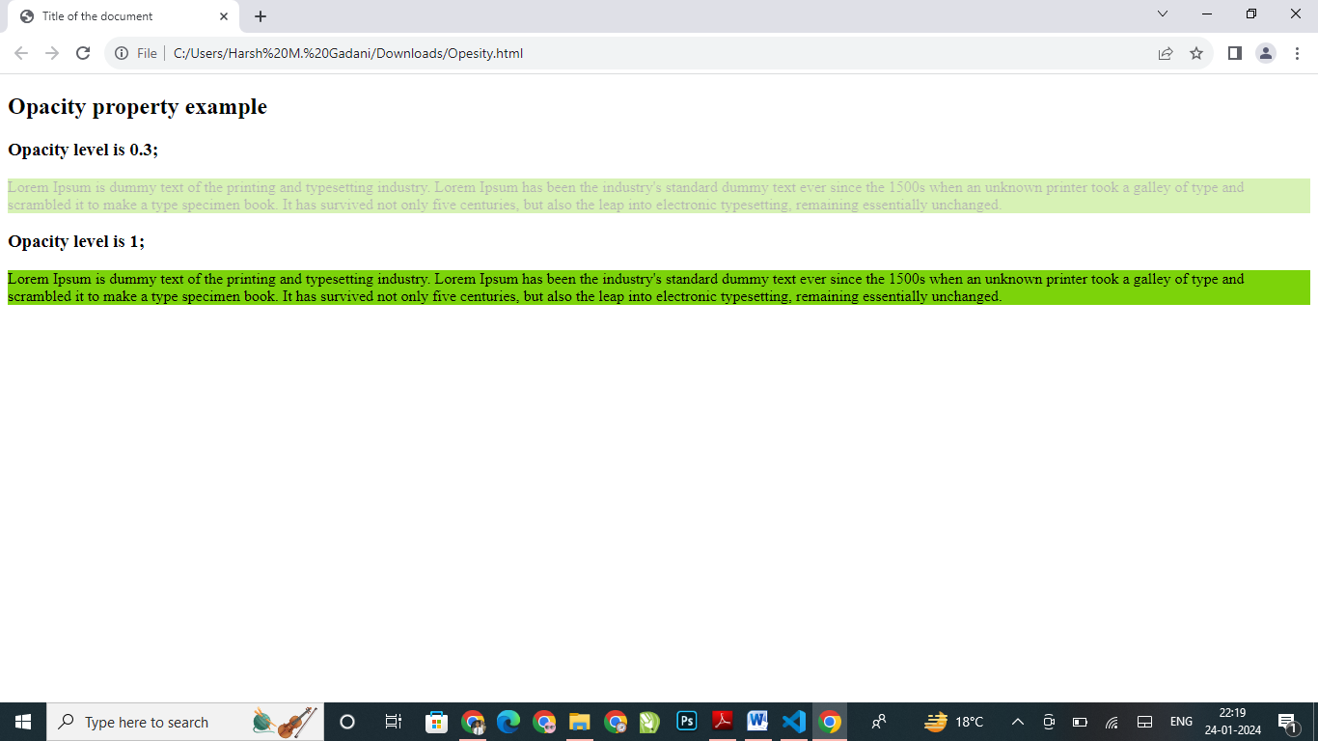

**Q : How can the background color of an element be changed?**

Ans: HTML and CSS, background color property.  To add or change background color in HTML, simply add inline CSS to your code.

The background-color of different elements in [CSS](https://www.geeksforgeeks.org/css/). The background-color property of CSS is used to set the background of an element.

**In example:**

**CSS**

**<body style="background-color:#33475b">**

In the past, you could use the bgcolor attribute to change the background color of a page or element.

Say you wanted to change the background color of a web page to maroon. You would have simply added the bgcolor attribute in the opening body tag and set it to the hex color code #800000.

**In example:**

**HTML**

**<body background-color="#800000">**

this attribute has been deprecated in the latest version of HTML and replaced by a much better alternative, the CSS background-color property. Using this property, you can add and change background colors on your website.

**Q : How can image repetition of the backup be controlled?**

Ans: the image repetition of the backup is controlled in CSS. This task can be achieved by using the background-repeat property that will help us to control the repetition of the image.

The background-repeat property in CSS is used to repeat the background image both horizontally and vertically. It also decides whether the background image will be repeated or not.

**Syntax:**

**Background-repeat: repeat | repeat-x | repeat-y | no-repeat | initial | inherit;**

**Q : What is the use of the background-position property?**

Ans: The background-position property sets the starting position of a background image.

CSS Syntax:

**background-position: *value*;**

**----**

**body {**

**background-image: url(C://desktop/abc.jpg);**

**background-repeat: no-repeat;**

**background-attachment: fixed;**

**background-position: center top;**

**}**

**Q : Which property controls the image scroll in the background?**

Ans: The property that is used to control the scrolling of an image in the background.

The **background-attachment** property in CSS is used to specify the kind of attachment of the background image with respect to its container. It can be set to scroll or make it remain fixed. It can be applied to all HTML elements.

**Syntax:**

background-attachment: scroll | fixed | local | initial | inherit;

**Q : Why should background and color be used as separate properties?**

Ans: the background and color are the separate properties if they should always be set together?

* It enhances the legibility of style sheets, The background property is a complex property in CSS, and if it is combined with color, the complexity will further increase.
* Color is an inherited property while the background is not. So this can make confusion further.

**Q : How to center block elements using CSS1?**

Ans: The Center Block Elements To centrally align the block elements, we can simply make use of the <center> tag.

All the elements within the <center> tag will be centrally aligned.

**Q : How to maintain the CSS specifications?**

Ans: The CSS specifications are maintained by the World Wide Web Consortium Even though every browser supports CSS, there are many inconsistencies in the supported specification version. Some browsers even have their own implementation of the specification and have proprietary (vendor) prefixes.

**Q : What are the ways to integrate CSS as a web page?**

Ans : HTML is a Hyper Text Markup Language, whereas CSS is a style sheet language. It is responsible for describing the presentation of an HTML & CSS specifies how elements should appear on a screen, on paper, in speech, or in other forms of media.

CSS may be added to HTML in three different ways.

* To style a single HTML element on the page, use Inline CSS in a style attribute.
* By adding CSS to the head section of our HTML document, we can embed an internal stylesheet.
* We can also connect to an external stylesheet that separates our CSS from our HTML.

**Q : What is embedded style sheets?**

Ans : Embedded style sheets refer to when you embed style sheet information into an HTML document using the [<style>](https://www.quackit.com/html/tags/html_style_tag.cfm) element. You do this by embedding the style sheet information within open [<style> </style>](https://www.quackit.com/html/tags/html_style_tag.cfm) close tags in the head of your document.

**<style>**

**p {**

**font-family: georgia, serif;**

**font-size: x-small;**

**}**

**hr {**

**color: #ff9900;**

**height: 1px;**

**}**

**a:hover {**

**color: #ff0000;**

**text-decoration: none;**

**}**

**</style>**

**Q : What are the advantages and disadvantages of using external style sheets?**

Ans : Cascading Style Sheets, as CSS, is a stylesheet language used for HTML CSS allows developers to define how elements on a web page develop, including Layout, tag, colors, fonts, and spacing. It simplifies the process of styling web content

**Advantages of CSS**

1. Separation of Content and Style

One of the most significant advantages of CSS is its ability to separate content from presentation. This separation enhances the maintainability of web pages as changes to the styling can be made without altering the underlying HTML structure. This also promotes a cleaner, more organized codebase.

2. Consistency

CSS enables consistent styling across an entire website or multiple pages. This is one of the many advantages of using CSS. By creating a single external CSS file and linking it to multiple web pages, you ensure a uniform look and feel. This reduces redundancy and makes it easier to update styling elements globally.

3. Faster Loading Times

External CSS files can be cached by web browsers, allowing them to load faster on subsequent visits. This results in a better user experience, especially for returning visitors.

4. Responsive Design

With CSS, you can create responsive web designs that adapt to different screen sizes and devices. This is another main one among advantages of cascading style sheets. This is crucial in the era of mobile browsing, as it ensures your website looks and functions well on various platforms.

5. Ease of Maintenance

Modifying the appearance of a website is more straightforward with CSS. You can quickly make changes to fonts, colors, and layouts by updating a few lines of code in the CSS file, rather than manually editing each HTML element.

6. Accessibility

CSS allows developers to improve web accessibility by controlling the presentation of content. Properly structured CSS can make a website more accessible to individuals with disabilities, enhancing inclusivity.

7. Print-Friendly Pages

CSS can be used to create printer-friendly versions of web pages. This is particularly useful for e-commerce websites, blogs, or any content-heavy sites where users might want to print articles or product information.

8. Global Styling

External CSS files can be linked to multiple web pages, making it easy to apply consistent styling across an entire website. This saves time and ensures a cohesive design.

9. Efficient Updates

When you need to update the styling of a website, you can make changes in one central CSS file. This means that updates are applied universally, reducing the risk of inconsistencies.

10. Animations and Effects

CSS allows for animations and transitions, enhancing the user experience. You can create interactive elements without relying on JavaScript or other scripting languages.

**Disadvantages of CSS**

Now that we've explored what are the advantages of CSS, let us take a look at what are the disadvantages of CSS.

1. Browser Compatibility

CSS may render differently in various web browsers, leading to inconsistencies in the visual presentation. Developers often need to write browser-specific CSS code or use vendor prefixes to ensure compatibility.

2. Learning Curve

One among the main disadvantages of cascading style sheets is that while it is essential for web development, it can be complex, especially for beginners. Mastering CSS requires understanding selectors, properties, values, and the box model, which can be overwhelming.

3. Lack of Security

CSS itself does not offer security features, and it can be vulnerable to attacks like Cross-Site Scripting (XSS) when used inappropriately. Developers must be cautious when implementing CSS to prevent security risks.

4. Limited Layout Control

CSS has limitations when it comes to controlling complex layouts. Achieving specific layouts, such as equal-height columns, can be challenging without resorting to workarounds or additional technologies like Flexbox or Grid.

5. Performance Impact

Extensive or poorly optimized CSS files can slow down page load times. It's essential to minimize and optimize CSS to maintain optimal website performance.

6. Overriding Styles

The "cascading" nature of CSS can sometimes lead to unexpected styling conflicts. Specificity and the order in which styles are applied can result in unintended consequences.

7. Maintenance Challenges

As websites grow and evolve, maintaining and refactoring CSS can become complex and time-consuming. It's crucial to follow best practices and use naming conventions to keep styles manageable.

**Q : What is the meaning of the CSS selector?**

Ans : In CSS, selectors are used to target the HTML elements on our web pages that we want to style. There are a wide variety of CSS selectors available, allowing for fine-grained precision when selecting elements to style. In this article and its sub-articles we'll run through the different types in great detail, seeing how they work.

|  |  |
| --- | --- |
| **Prerequisites:** | Basic software installed, basic knowledge of working with files, HTML. CSS works |
| **Objective:** | How CSS selectors work in website layout color, font,and much more. |

**Q : What are the media types allowed by CSS?**

Ans : One of the most important features of style sheets is that they specify how a document is to be presented on different media: on the screen, on paper, with a speech synthesizer, with a braille device, etc.

We have currently two ways to specify media dependencies for style sheets −

* Specify the target medium from a style sheet with the @media or @import at-rules.
* Specify the target medium within the document language.

## The @media rule

## An *@media* rule specifies the target media types (separated by commas) of a set of rules.

Given below is an example –

<style tyle = "text/css">

<!-- @media print {

body { font-size: 10pt }

}

@media screen {

body { font-size: 12pt }

}

@media screen, print {

body { line-height: 1.2 }

} -->

</style>

## Media Types:

## 1 All

## Suitable for all devices.

## 2 Aural

## Intended for speech synthesizers.

## 3 Braille

## Intended for braille tactile feedback devices.

## 4 Embossed

## Intended for paged braille printers.

## 5 Handheld

## Intended for handheld devices (typically small screen, monochrome, limited bandwidth).

## 6 Print

## Intended for paged, opaque material and for documents viewed on screen in print preview mode. Please consult the section on paged media.

## 7 Projection

## Intended for projected presentations, for example projectors or print to transparencies. Please consult the section on paged media.

## 8 Screen

## Intended primarily for color computer screens.

## 9 Tty

## Intended for media using a fixed-pitch character grid, such as teletypes, terminals, or portable devices with limited display capabilities.

## 10 Tv

## Intended for television-type devices.

**Q : What is the rule set?**

## Ans : A rule set is a collection of one or many rules that are executed together as a single unit against a specific set of records and generate several levels of statistics.